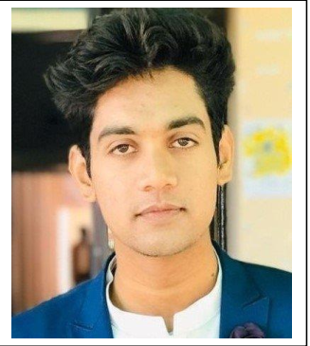

ASAD RAZA MAHMOOD

***Electrical Engineer*** House No:130-B River view cooperative housing society

*Raiwind road Lahore*

***+92 324 0403582***

[*asadrazamahmood@gmail.com*](mailto:asadrazamahmood@gmail.com%20)

**Personal Statement**

I am a hardworking, self-motivated professional and committed employee who feels most comfortable in a role whereby pressure is very much part of everyday working life. I have applied for this position because I feel strongly that I have the necessary skills, qualities and attributes to not only carry out each of the duties to a high standard, but also help your organization move forward positively and innovatively through hard work and determination.

# Awards and Achievements

* + Member of IEEE (Institute of Electrical and Electronics Engineers).
  + Awarded certificate of 1st Position in Pakistan Atomic Energy Commission (PAEC) Debate Competition.
  + Got Full Fee Reimbursement scholarship in Bachelor’s for attaining GPA greater than

3 in at UET.

* + Awarded Certificate of Completion of Software Quality Assurance training in CUREMD under supervision of PASHA.

|  |  |  |
| --- | --- | --- |
| **Education** |  |  |
| 2016-2020 | Bachelor’s in University of Engineering and Technology Lahore, Pakistan | 3.29 CGPA |
| 2014-2016 | HSSC Pre-Engineering | 81.6% |
| 2012-2014 | SSC Sciences | 92.6% |

**Work Experience**

## *Internee At CUREMD (Oct-2022 to Dec-2022)*

* Programming Fundamentals
* Studied Software Quality Assurance
* Studied Soft skills

## *Trainee Engineer At Mobiserve Pvt Ltd/Zong Project (May-2021 to sep-2022)*

* CP Analyst (High Billing Analysis)
* Quality Checking of alarms on Site end.
* Remote Monitoring System (RMS) Availability.

## *Trainee Engineer at SHAA Avant-Garde Technologies (Dec-2020 to Mar-2021)*

* Evaluation of photovoltaic (PV) modules and inverters
* Site-specific engineering analysis and evaluation of cost-effective PV projects
* Shading analysis and simulation of PV system to optimize system’s efficiency
* Formation of connection diagrams, protection circuit and wire sizing
* Battery sizing
* Quality Control Inspection
* Technical support to installation teams
* Testing and commissioning of PV projects

## *Internship at NTDC (Jul-2019 to Aug-2019)*

* Internee at Grid Station
* Internee at standards & Specifications Department

## Technical Skills

* **Languages:** Assembly, C , C# , Java.
* **Hardware:** Arduino, MPU 6050, Raspberry-Pie, Bluetooth Module, Ultrasonic Sensor.
* **Software:** Selenium, Jira, MS Office, Visual Studio, Eclipse, Power World Simulator, Proteus.

**Semester Projects**

* Gesture Controlled Gun
* DC Microgrid Integration of Hybrid PV & Battery
* Obstacle Avoiding Robot (Arduino Microcontroller)
* Self-Balancing Robot (MPU 6050 & Arduino)
* Bluetooth Controlled Home Automation
* Image Encryption & Decryption

**Interests**

* E-Commerce
* Travelling
* Writing Poetry
* Football